
End of Life Care in Care Homes during the Covid-19 pandemic
It is recognised that people living in care homes are often frail with complex needs and varying levels of dependence. Around 80% of people living in care homes are likely to be in their last year of life.
Many of those living in care homes will be at greater risk if they were to contract COVID-19 due to conditions such as frailty, cognitive impairment including dementia, physical disability, neurological conditions and multiple comorbidities. For many, hospital admission during the pandemic may be inappropriate which means additional support within the care home setting may be necessary, more comfortable and in the best interests of those in the last days of life.
The following information has been compiled by the Palliative Care in Partnership (PCiP) Programme, as an overview of mechanisms and resources in place in Northern Ireland to support care homes caring for people in the last days of life during the Covid-19 pandemic:
- Covid-19: Management of Symptoms in the Last Days of Life (RPMG April 2020)

The Regional Palliative Medicines Group (RPMG) working with the NI Specialist Palliative Care Pharmacy Group and supported by the PCiP programme have developed specific symptom management guidance for people with Covid-19 in the last days of life. This guidance (link below) is relevant for use in both secondary and primary care settings (including care homes).
Covid- 19: Management of Symptoms in the last days of life (RPMG April 2020) | 
- Regional arrangements for palliative care medicines during Covid-19 pandemic
In response to the COVID-19 pandemic, the Health and Social Care Board (HSCB) has been working to support the availability of essential medicines for palliative/end of life patients who are managed in primary care settings, including care homes.

Community Pharmacy Palliative Care Network
Community Pharmacy Palliative Care Network pharmacies are spread throughout Northern Ireland and aim to increase access to community pharmacy palliative care services. They can supply medicines from the palliative stock list or be contacted for advice. Please see the leaflet below for more information.
Community Pharmacy Palliative Care Network  (including regional palliative stock list) | 
More information about Palliative Care Pharmacy Services can be accessed here: http://www.hscbusiness.hscni.net/services/2481.htm
Urgent Pandemic Packs for Nursing Homes
HSCB has also arranged the distribution of Urgent Pandemic Packs to Nursing Homes with 59 beds or more. The medication in these packs should be used to provide timely access to patients requiring clinically urgent medication and guidance to support the use of these packs will be issued to eligible nursing homes prior to delivery w/c 13th April 2020. For more information on the Urgent Pandemic Packs and a list of the Nursing Homes who will receive them please visit the link below:
http://www.hscbusiness.hscni.net/services/3137.htm
Policy for assessment of un-used prescribed medicines for the potential to re-use in care homes (nursing and residential care homes) and hospices
In response to the COVID-19 pandemic, RQIA, PHA, Trust and HSCB Pharmacy Colleagues have been working together to develop policies and guidance across a range of medicines management areas to support services across care settings.
As part of this, a Policy for Assessment of Un-used prescribed Medicines for the potential to Re-use in Care Homes (Nursing and Residential Care Homes) AND Hospices has been developed and can be accessed at the following link: http://www.hscbusiness.hscni.net/services/3141.htm
This policy will take immediate effect during the Covid-19 pandemic and will remain in place until 30th June 2020 or earlier if stood down following further correspondence.
- Advance Care Planning
Ideally all people living in care homes should already have documented Advance Care Planning Summaries. Further information regarding advance care planning and using the ‘Your Life, Your Choices – Plan ahead’ resources can be found in the resources section of the Palliative Care in Partnership website https://pcip.hscni.net/resources/
If advance care planning discussions and decisions have already taken place with regards to the care preferences of the person then those decisions should be reviewed and confirmed (or changed) in light of Covid-19 with person/ those important to them (if the person lacks capacity).
The nature of Covid-19 presents a risk to all people living in care homes even those which are currently considered stable. Anticipatory plans in case of the person becoming infected should be discussed with and for each person to establish clear understanding of goals of care. These discussions may include:
- Use of IV/SC fluids
- Use of oxygen or antibiotics (if appropriate)
- When/if to transfer the person to hospital
- DNACPR and/or ADRT
- Their wishes for the last days of life
All discussions should be clearly documented and if necessary involve the person’s GP who can document agreed decisions relating to medical interventions and share these via the patient’s Key Information Summary (on NIECR) so that they are available to colleagues in other care settings.
In the event that the person is admitted to hospital (or another care setting) for treatment the care home should ensure that details of their advance care planning preferences are transferred with the person.
- Having difficult conversations

The Scottish Quality Safety Fellows – NHS Scotland have developed a ‘roadmap’ to support health care professionals who may not be routinely used to discussing end of life decisions, death and dying with people or those important to them. Please see Appendix 1 for more information.

- Support from palliative care professionals
The existing Specialist Palliative Care services offered by each HSC Trust and the local hospices across Northern Ireland will continue to operate, although some face to face services may be restricted in line with Government advice and social distancing measures.
Some of these providers are also enhancing their services to offer additional telephone advice to health professionals (including care home staff) caring for people in their last days of life.

Please note the policies for giving advice and hours of operation may vary across these services.
Belfast HSC Trust | Call 028 9079 6220 for advice to District Nurses, Care Homes and the public.
Northern HSC Trust | Call 028 9442 4832  Advice available Monday – Friday, 9am – 5pm
South Eastern HSC Trust | Direct Line for Palliative Care: 028 9041 3629
Southern HSC Trust | Palliative Care Advice Line: 028 3756 0592  9am -10pm, 7 days per week – providing advice for any health care professional caring for palliative or end of life patients in the Southern Trust area.
Western HSC Trust | Specialist Palliative Care Hospital Team  (Monday – Friday 9am – 5pm) :  - Altnagelvin 028 7161 1431 Ext 212407/08  - SWAH 028 6638 2197 Ext 252000  Foyle Hospice (Monday – Sunday 24hrs)  028 7135 1010
Northern Ireland Hospice | 24/7 Palliative Care Advice line: 07587 135335
- Verification of Life Extinct
It is recognised that during the Covid-19 pandemic there is a need to increase the number of people appropriately trained to verify life extinct. Increased capacity in appropriately trained staff who can verify life extinct will relieve pressures on medical practitioners particularly in community settings.

Through RQIA, the Chief Medical Officer and Chief Nursing Officer have written to all independent care providers (including nursing and residential homes) requesting that providers encourage nurses to access free on-line training which is being offered by the HSC Clinical Education Centre. For more information please visit https://cec.hscni.net/ and search for ‘Verification of Death’ under ‘Programmes’.

- Covid-19 Guidance surrounding death
A range of guidance surrounding deaths in Northern Ireland during Covid-19 has been developed and is available on the Department of Health website at the link below:
https://www.health-ni.gov.uk/publications/covid-19-guidance-surrounding-death
This guidance includes new arrangements for completing and issuing Medical Certificates of Cause of Death and guidance for verification of life extinct during Covid-19.

All of the resources in this briefing and more information about caring for people in the last days of life during Covid-19 can be found on our website:
https://pcip.hscni.net/covid-19/information-for-hsc-professionals/

Alternatively if you have any queries or require more information please contact:
Diane Walker
Palliative Care in Partnership Macmillan Programme Manager
diane.walker2@hscni.net

Appendix 1: Covid-19 Roadmap for having difficult conversations
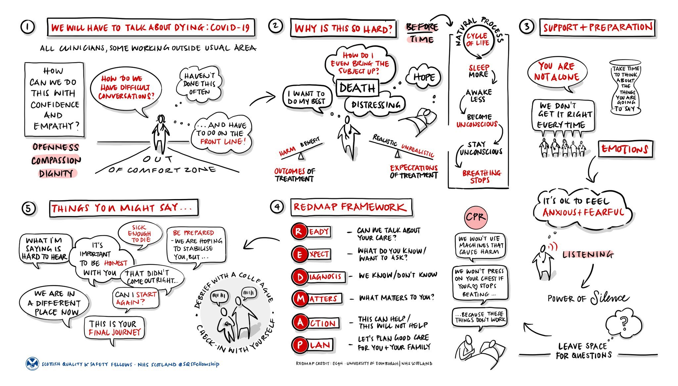

Royal College of Physicians: Talking about dying: How to begin honest conversations about what lies ahead. October 2018.

